VISUALISATION FOR OUR DATA

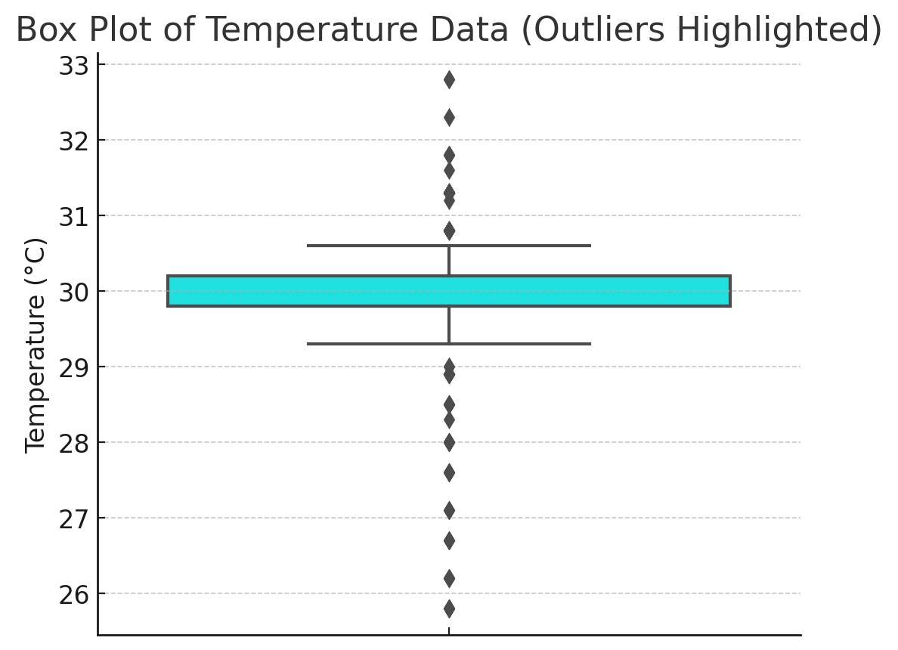

***The box plot visualizes temperature data distribution, highlighting outliers beyond the normal range.***

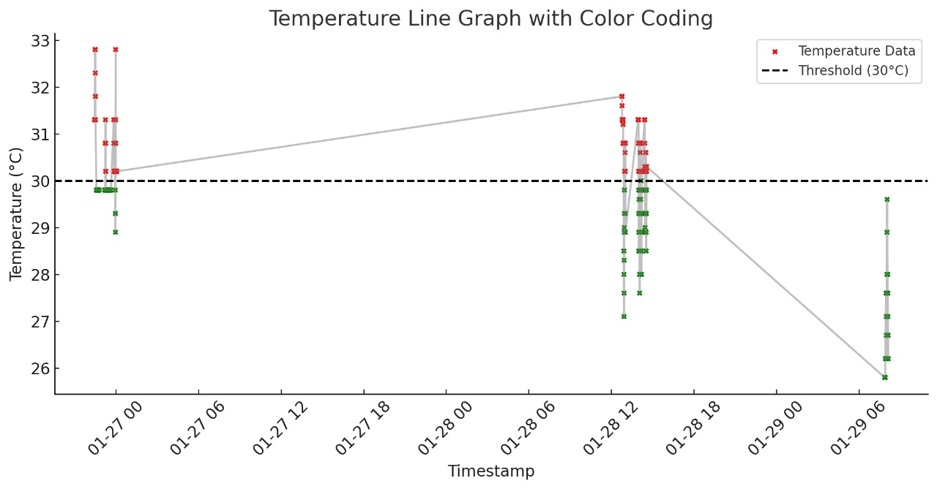***The line graph shows temperature variations over time with color-coded data points, highlighting values above (red) and below (green) the 30°C threshold.***

GRAPH WITH RANDOM DATA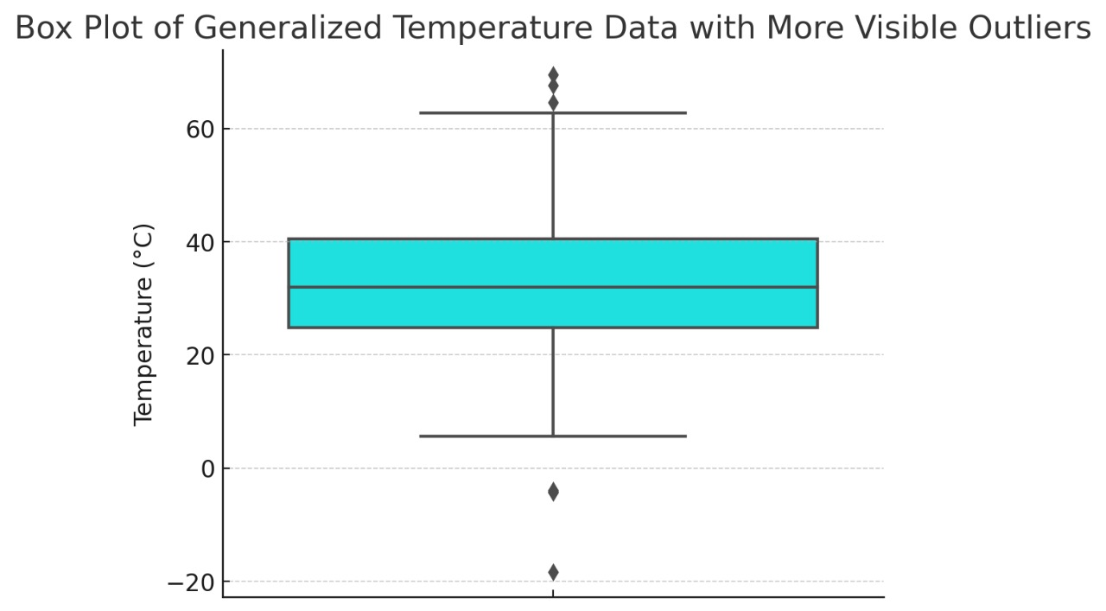

***The box plot visualizes generalized temperature data, highlighting a wide range with multiple outliers above 60°C and below 0°C, indicating extreme variations.***

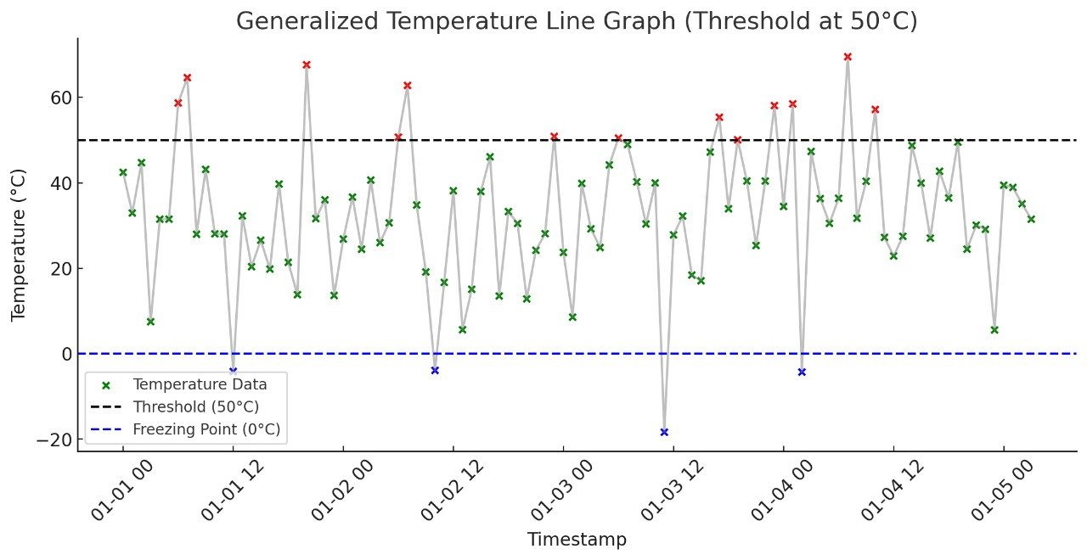***The line graph shows temperature variations over time, marking extremes above 50°C (red) and below 0°C (blue).***

Circuit connection

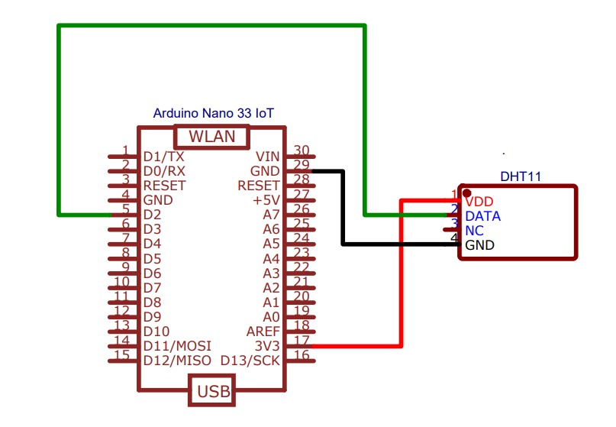***DHT11 connects to Arduino Nano 33 IoT: VDD to 3.3V, GND to GND, DATA to D2 for temperature readings.***

Circuit Image :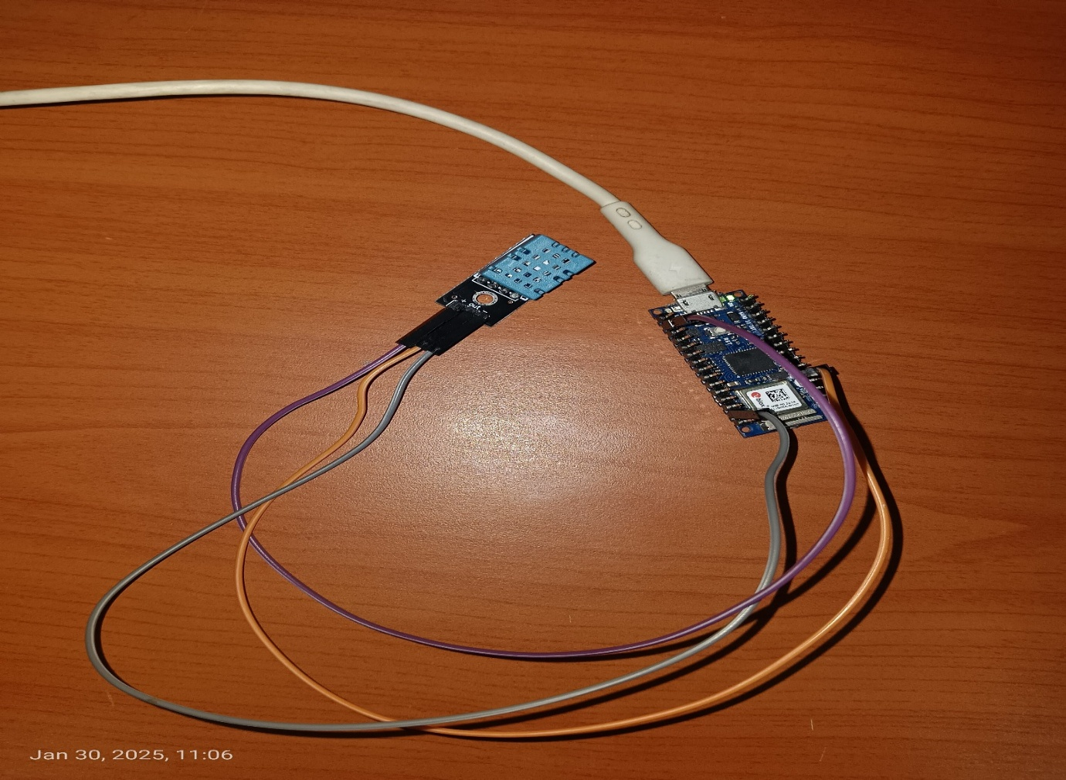

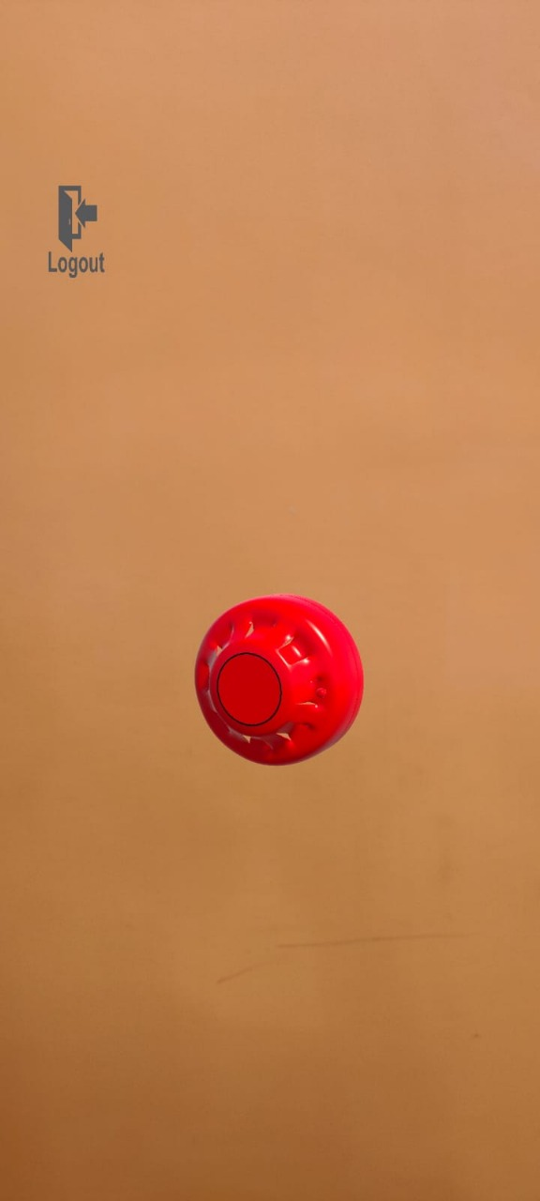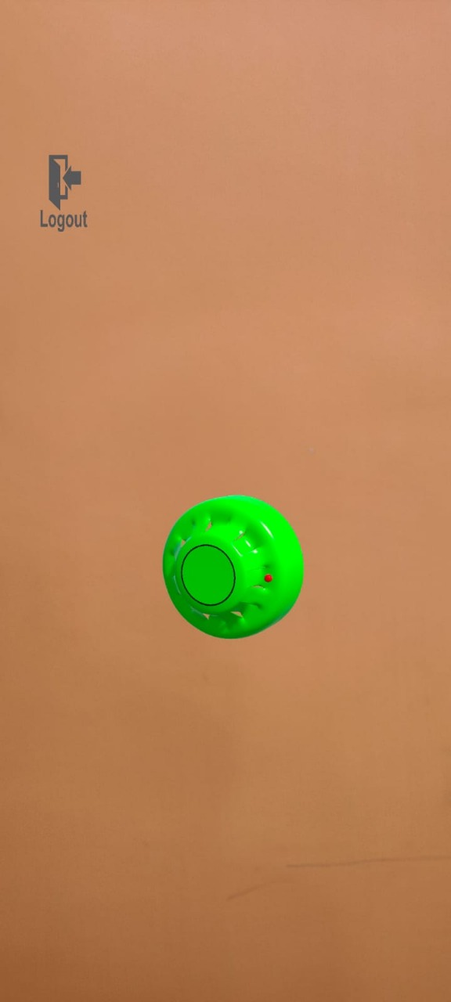  
OUTPUT IMAGES:

**Green Indicator**: When the measured temperature remains below a predefined threshold, the object appears green, signifying safe conditions.

**Red Alert**: If the temperature exceeds the threshold, the object turns red, indicating a warning or hazardous situation.

FLOWCHART: 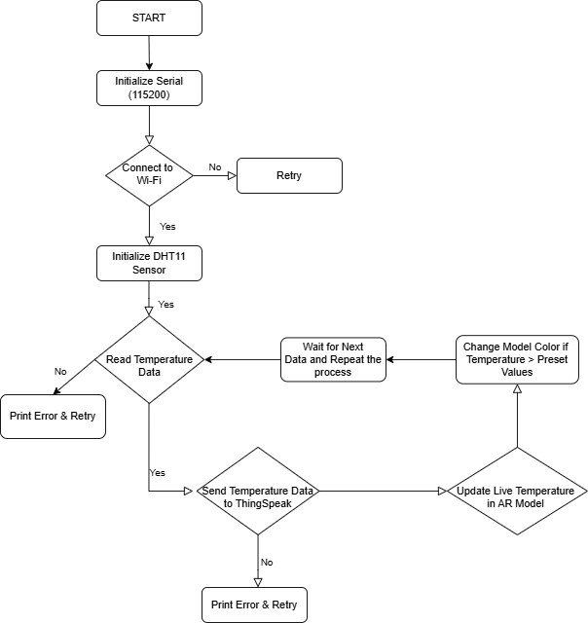

***[The flowchart depicts capturing IoT temperature data, processing it, and visualizing it in AR]***

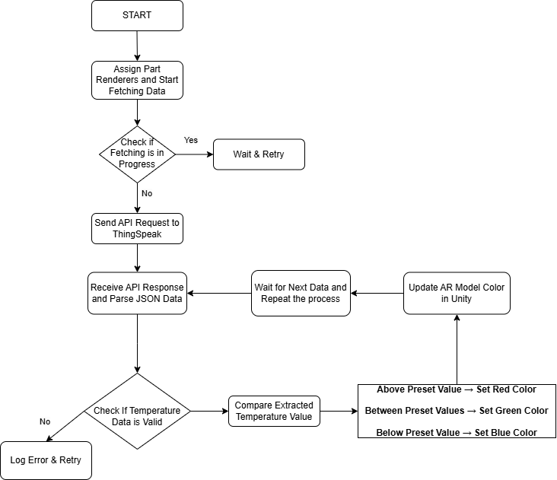

***[The flowchart illustrates fetching temperature data via API, validating it, and updating the AR model's colour in Unity based on preset thresholds]***

**Journal References:**

1. Kamil, M. H. F. M., Mustafa, E. H., & Norizan, A. R. (2024). Innovative Solution for Kids with Diabetes: Augmented Reality Mobile Application for Insulin Intake. In *Board Diversity and Corporate Governance* (pp. 117-130).
2. Khor, C. Y., & Mubin, S. A. (2024). AR Mobile Application for Enhancing National Museum Heritage Visualization. International Journal of Software Engineering and Computer Systems, 10(1), 1-19.
3. Babu, S. P. (2024). Focus AR: A study of Focus-based Mobile AR App in Industrial Training.
4. Qi, W., Wang, W., Han, H., Yu, S., Gu, Y., & Liu, Y. (2024, July). Augmented reality campus navigation for both indoor and outdoor spaces based on ARCore. In Third International Conference on Electronic Information Engineering and Data Processing (EIEDP 2024) (Vol. 13184, pp. 679-685). SPIE.
5. Badiee Razavi, M. (2024). Using Augmented Reality Technology in Geometry Learning for Elementary School Students.
6. Campos, J. P. A., Madalozzo, G. A., Alves, A. L. S. A., & Rieder, R. (2024). ARFood: an augmented-reality food diary app for asynchronous collaborative interaction. Journal on Interactive Systems, 15(1), 750-761.
7. Simon, J. (2023). Augmented Reality Application Development using Unity and Vuforia. Interdisciplinary Description of Complex Systems: INDECS, 21(1), 69-77.
8. Simon, J., Gogolák, L., Sárosi, J., & Fürstner, I. (2023, July). Augmented reality based distant maintenance approach. In Actuators (Vol. 12, No. 7, p. 302). MDPI.
9. Zhang, L., Xu, F., Liu, Y., Zhang, D., Gui, L., & Zuo, D. (2023). A posture detection method for augmented reality–aided assembly based on YOLO-6D. The International Journal of Advanced Manufacturing Technology, 125(7), 3385-3399.
10. Kanivets, O. V., Kanivets, I. M., & Gorda, T. M. (2022). Development of an augmented reality mobile physics application to study electric circuits. Educational Technology Quarterly, 2022(4), 347-365.